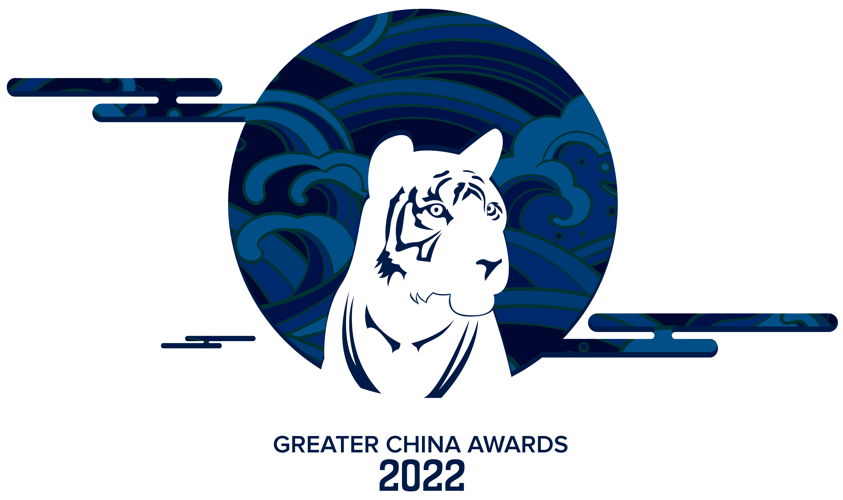
NORTH WEST ENGLAND GREATER CHINA AWARDS 2022

North West England

China Business Award 2011

Entry Form

Business Award Entry

This award is for businesses with innovative, resilient & successful partnerships with Greater China for over 3 years. Any impacts on your sales growth arising from the pandemic, and the supply chain/logistics situation, will be taken into account when assessing entries.

Name | Position
Company Name | Website
Address
Telephone | Mobile
Email | Social media handle (hashtag etc)
Description of main products/services your company offers:

Date of first links with Greater China:

In your submission, please elaborate on the following areas:
- What is your approach to penetrating the mainland China, Hong Kong, Macau, and Taiwan markets?

- What do you consider to be the most innovative aspect of your entry technique?

- How do you measure your current success in Greater China?

- Please state the following:
Current turnover:
No. of employees:
Export sales for the past 5 years: Year 1 -
Year 2 -
Year 3 -
Year 4 -
Year 5 -
- If any, please provide us any additional evidence, such as charts and graphs, to prove the growth / success of your business with Greater China throughout the last 5 years.

- What is your longer-term strategy for your business in Greater China?

Organisations entering this award agree that their data will be shared.

[ ] Organisations entering this award are in agreement that their data will be shared (please tick). To find out more about how we use personal information, please see our full privacy policy here. It is also available in hard copy format upon request.

Completed by: ……………………………………………………………………………………. Date ………………………………..

The Greater China Business Award 2022 will be judged on the following criteria:
• Your clear business objectives in Mainland China, Hong Kong, Macau, or Taiwan.
• Your approach to penetrating the Greater China market and how successful this has been.
• Evidence of partnership between Greater China and the North West, and the impact this has had on the overall success of the business.
• Demonstration of how your business has encouraged a two-way flow of personnel and know-how, or the mutual understanding of the UK and Chinese cultural and business environment.
• Your long-term business strategy in Greater China.

The closing date for receipt of the application is by email or by post by Monday 31st January 2022 to:

GREATER CHINA AWARDS PANEL 2022
Ms Miho Hatakeyama
North West International Trade Team
Lee House, 90 Great Bridgewater Street, Manchester M1 5JW
Email: miho.hatakeyama@tradenw.org Telephone: 07789 953 422

